.

**Dept of Artificial Intelligence and Machine Learning** | **Rajalakshmi Engineering College**

104

# - Strings in Python

**Ex. No. : 6.1 Date:** 13/4/24

.

**Dept of Artificial Intelligence and Machine Learning** | **Rajalakshmi Engineering College**

105

**Register No.:231501003 Name: ABDUL BASARUTHEEN B**

## Count Chars

Write a python program to count all letters, digits, and special symbols respectively from a given string.

For example:

Input Result rec@123

3

3

1

**PROGRAM**

x = str(input()) c1, c2, c3 = 0, 0, 0

for i in x:

if i.isalpha(): c1 += 1

elif i.isdigit(): c2 += 1

else:

c3 += 1

print(c1) print(c2) print(c3)

##### Output:

.

**Dept of Artificial Intelligence and Machine Learning** | **Rajalakshmi Engineering College**

106

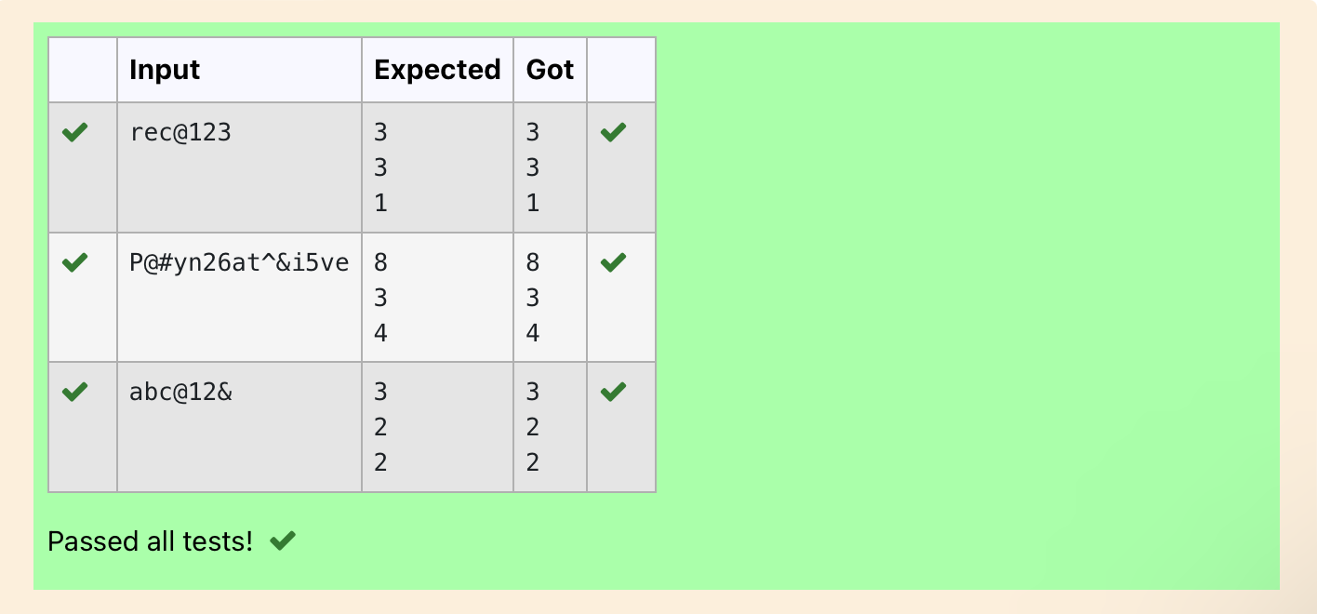

**Ex. No. : 6.2 Date:** 13/4/24

.

**Dept of Artificial Intelligence and Machine Learning** | **Rajalakshmi Engineering College**

107

**Register No.:231501003 Name: ABDUL BASARUTHEEN B**

## Decompress the String

Assume that the given string has enough memory. Don't use any extra space(IN- PLACE).

Sample Input 1 a2b4c6

Sample Output 1 aabbbbcccccc

**PROGRAM**

s=input() l1=[]

l2=[]

s2=""

for i in range(0,len(s)):

if((ord(s[i])>=65 and ord(s[i])<=90) or (ord(s[i])>=97 and ord(s[i])<=122)): l1.append(s[i])

else:

s2=s2+s[i] continue

if s2!="": l2.append(s2)

s2="" i=-1

while(s[i]==ord(s[i])>=48 and ord(s[i])<=57): s2=s2+s[i]

i-=1

continue l2.append(s2) '''print(l1,l2)'''

for i in range(0,len(l2)): l2[i]=int(l2[i])

for i in range(0,len(l1)): print(l1[i]*l2[i],end="")

**Output:**

.

**Dept of Artificial Intelligence and Machine Learning** | **Rajalakshmi Engineering College**

108

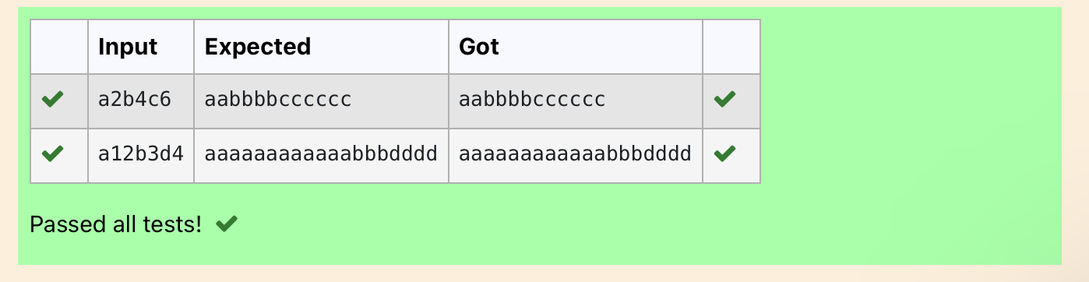

**Dept of Artificial Intelligence and Machine Learning** | **Rajalakshmi Engineering College**

109

**Ex. No. : 6.3 Date:** 13/4/24

**Register No.:231501003 Name: ABDUL BASARUTHEEN B**

## First N Common Chars

Two string values S1, S2 are passed as the input. The program must print first N characters present in S1 which are also present in S2.

Input Format:

The first line contains S1. The second line contains S2. The third line contains N.

Output Format:

The first line contains the N characters present in S1 which are also present in S2. Boundary Conditions:

2 <= N <= 10

2 <= Length of S1, S2 <= 1000 Example Input/Output 1:

Input:

abcbde cdefghbb 3

Output:

bcd

Note: b occurs twice in common but must be printed only once.

**PROGRAM**

s1 = input().strip() s2 = input().strip() n = int(input()) common_chars = '' for char in s1:

if char in s2 and char not in common_chars: common_chars += char

if len(common_chars) == n: break

print(common_chars)

.

Output:

.

**Dept of Artificial Intelligence and Machine Learning** | **Rajalakshmi Engineering College**

110

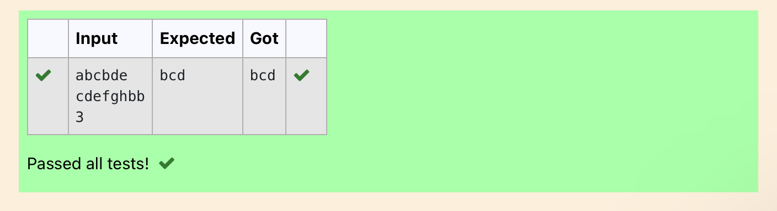

**Ex. No. : 6.4 Date:** 13/4/24

.

**Dept of Artificial Intelligence and Machine Learning** | **Rajalakshmi Engineering College**

111

**Register No.:231501003 Name: ABDUL BASARUTHEEN B**

## Remove Characters

Given two Strings s1 and s2, remove all the characters from s1 which is present in s2.

Constraints

1<= string length <= 200

Sample Input 1 experience

enc

Sample Output 1 xpri

**PROGRAM**

str1=str(input()) str2=str(input()) l1=list(str1) l2=list(str2)

for i in range(0,len(l2)): for j in range(0,len(l1)):

if l2[i] in l1: l1.remove(l2[i])

str3=""

for i in range(0,len(l1)): str3=str3+l1[i]

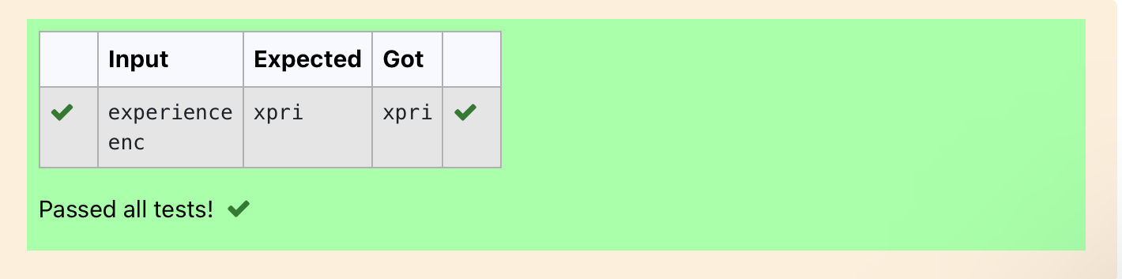print(str3) Output:

**Ex. No. : 6.5 Date:** 13/4/24

.

**Dept of Artificial Intelligence and Machine Learning** | **Rajalakshmi Engineering College**

112

**Register No.:231501003 Name: ABDUL BASARUTHEEN B**

## Remove Palindrome Words

String should contain only the words are not palindrome.

Sample Input 1

Malayalam is my mother tongue

Sample Output 1

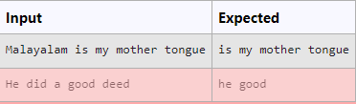is my mother tongue For example:

**PROGRAM**

x = input()

words = x.split() non_palindrome_words = []

for word in words: word_lower = word.lower()

if word_lower != word_lower[::-1]: non_palindrome_words.append(word_lower)

for word in non_palindrome_words: print(word, end=' ')

Output:

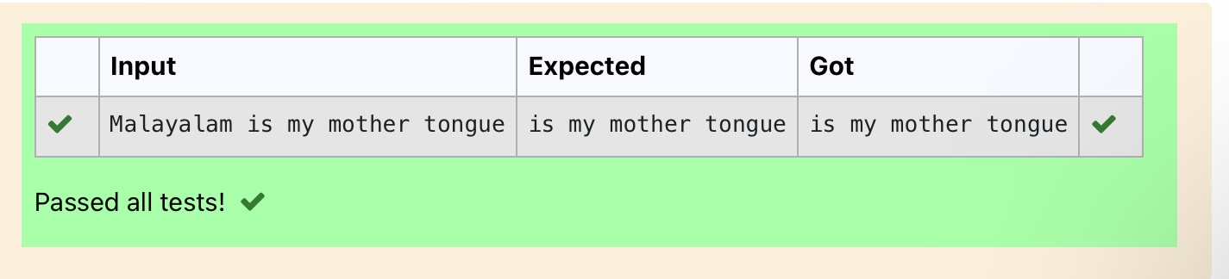

**Ex. No. : 6.6 Date:** 13/4/24

.

**Dept of Artificial Intelligence and Machine Learning** | **Rajalakshmi Engineering College**

113

**Register No.:231501003 Name: ABDUL BASARUTHEEN B**

## Return Second World in Uppercase

Write a program that takes as input a string (sentence), and returns its second word in uppercase.

For example:

If input is “Wipro Technologies Bangalore” the function should return “TECHNOLOGIES”

If input is “Hello World” the function should return “WORLD” If input is “Hello” the program should return “LESS”

NOTE 1: If input is a sentence with less than 2 words, the program should return the

word “LESS”.

NOTE 2: The result should have no leading or trailing spaces. For example:

Input Result

Wipro Technologies Bangalore TECHNOLOGIES Hello World WORLD

Hello LESS

**PROGRAM**

a=input() l=a.split() #print(l) if(len(l)<2):

print("LESS") else:

a=l[1] print(a.upper())

##### Output:

.

**Dept of Artificial Intelligence and Machine Learning** | **Rajalakshmi Engineering College**

114

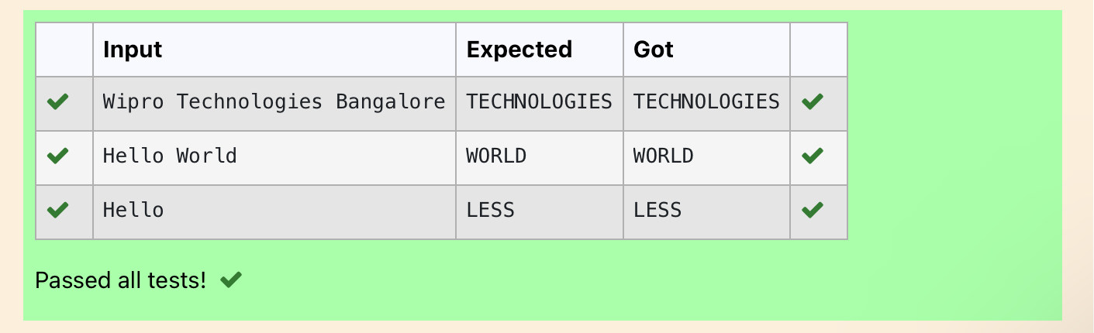

**Ex. No. : 6.7 Date:** 13/4/24

.

**Dept of Artificial Intelligence and Machine Learning** | **Rajalakshmi Engineering College**

115

**Register No.:231501003 Name: ABDUL BASARUTHEEN B**

## Revers String

Reverse a string without affecting special characters. Given a string S, containing special characters and all the alphabets, reverse the string without affecting the positions of the special characters.

Input:

A&B Output:

B&A

Explanation: As we ignore '&' and

As we ignore '&' and then reverse, so answer is "B&A".

For example:

Input Result

A&x# x&A#

**PROGRAM**

s = input().strip()

left, right = 0, len(s) - 1 s_list = list(s)

while left < right:

if not s_list[left].isalpha(): left += 1

elif not s_list[right].isalpha(): right -= 1

else:

s_list[left], s_list[right] = s_list[right], s_list[left] left += 1

right -= 1

result = ''.join(s_list) print(result)

##### Output:

.

**Dept of Artificial Intelligence and Machine Learning** | **Rajalakshmi Engineering College**

116

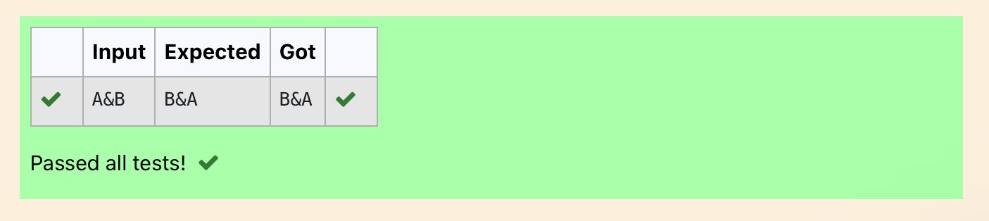

.

**Dept of Artificial Intelligence and Machine Learning** | **Rajalakshmi Engineering College**

117

**Ex. No. : 6.8 Date:** 13/4/24

**Register No.:231501003 Name: ABDUL BASARUTHEEN B**

## String characters balance Test

Write a program to check if two strings are balanced. For example, strings s1 and s2 are balanced if all the characters in the s1 are present in s2. The character’s position doesn’t matter. If balanced display as "true" ,otherwise "false".

For example:

Input Result Yn

PYnative True

**PROGRAM**

x = input() y = input() if x in y:

print("True") else:

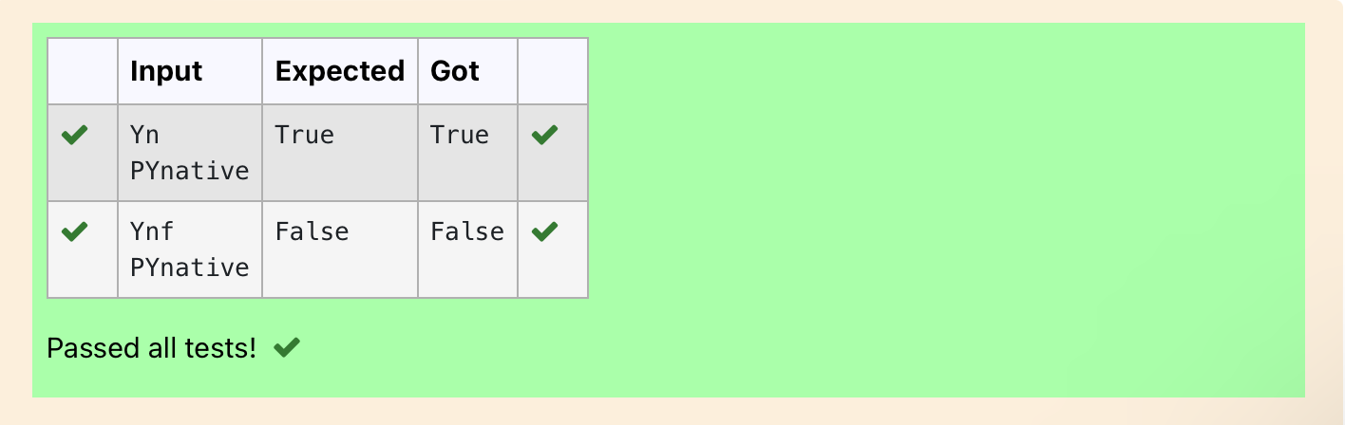print("False") Output:

**Ex. No. : 6.9 Date:** 13/4/24

.

**Dept of Artificial Intelligence and Machine Learning** | **Rajalakshmi Engineering College**

118

**Register No.:231501003 Name: ABDUL BASARUTHEEN B**

## Unique Names

In this exercise, you will create a program that reads words from the user until the user enters a blank line. After the user enters a blank line your program should display each word entered by the user exactly once. The words should be displayed in the same order that they were first entered. For example, if the user enters:

##### Input:

first second first third second

then your program should display:

##### Output:

first second third

**PROGRAM**

b = input() s1 =[]

c = 0

while b != " ": s1.append(b) b = input()

my_set = list(set(s1)) for i in s1:

for j in range(len(my_set)): if i == my_set[j]:

print(i)

my_set[j] = "0000"

##### Output:

.

**Dept of Artificial Intelligence and Machine Learning** | **Rajalakshmi Engineering College**

119

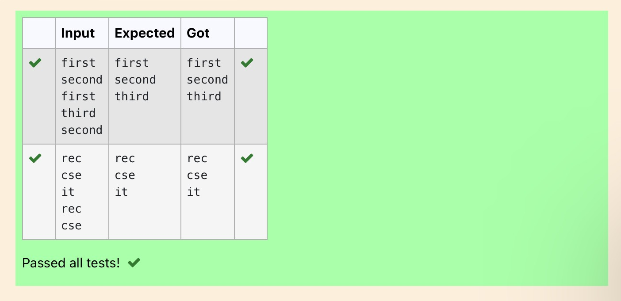

**Ex. No. : 6.10 Date:** 13/4/24

**Dept of Artificial Intelligence and Machine Learning** | **Rajalakshmi Engineering College**

120

**Register No.:231501003 Name: ABDUL BASARUTHEEN B**

## Username Domain Extension

Given a string S which is of the format [USERNAME@DOMAIN.EXTENSION,](mailto:USERNAME@DOMAIN.EXTENSION) the program must print the EXTENSION, DOMAIN, USERNAME in the reverse order.

##### Input Format:

The first line contains S.

##### Output Format:

The first line contains EXTENSION. The second line contains DOMAIN. The third line contains USERNAME.

##### Boundary Condition:

1 <= Length of S <= 100 Example Input/Output 1:

**Input**: [vijayakumar.r@rajalakshmi.edu.in](mailto:vijayakumar.r@rajalakshmi.edu.in)

**Output**: edu.in rajalakshmi vijayakumar.r

**PROGRAM**

b=0 c=0

a=input() if '@' in a:

b=a.index("@")

if "." in a: c=a.index(".")

print(a[c+1:])

print(a[b+1:c])

print(a[:b])

.

Output:

.

**Dept of Artificial Intelligence and Machine Learning** | **Rajalakshmi Engineering College**

121

